STATE LEVEL AGRICULTURE CENSUS CROP

PROJECT OVERVIEW AND OBJECTIVE
The objectives include understanding factors affecting crop yields, identifying high-performing and underperforming states, and generating actionable insights to improve agricultural output and resource allocation across regions.
An operational agricultural land holding is the fundamental unit for building effective policy decision in agricultural development. The dataset covers the indicators on total area, irrigated area and number of operational holdings, and it is disaggregated across social group, farmer size class and farmers group.

DATA SOURCES
- Source Description and Timeline : Indian Data Portal/ISB Ministry of Agriculture & Farmers Welfare Dataset
- Time Period : 2011 & 2016.
- Domain : Food & Agricultural

PROBLEM STATEMENT
- To analyse the forecast for the future year of crop production and gain the crop yield
- To analyse Year-over-year growth or decline in crop production
- To analyse Long-term trends in cultivated area, productivity, or output
- To Compare performance before and after certain years or policies (if time series is present)

ATTRIBUTE (COLUMN /FEATURES) DETAILS
ATTRIBUTE NAME | DATA TYPE | DESCRIPTION
Serial No | Numeric | Unique identifier for each Crop
Year | Numeric (Whole number) | Two Difference type of Year
State Name | String (Text) | List of the State Name
State Code | Numeric (Whole number) | Unique identifier for each State
Social Group | String (Text) | Unique identifier for Social Group
Farm Size Class | Numeric (Decimal) | Different Size of the Crop hold
Farm Size Category | String (Text) | Category for the Farm Size
Crop Name | String (Text) | Different type of Crop Name
Crop Code | Numeric (Whole number) | Unique identifier for Each Crop
Crop Type | String (Text) | Name of the Crop
Hold No State | Numeric (Whole number) | No. of hold no state
Irrigation Area | Numeric (Decimal) | Size of the Irrigated Area
Unirrigation Area | Numeric (Decimal) | Size of the Unirrigated Area
Total Area | Numeric (Decimal) | Total Size of the Area in State

TOOLS & TECHNOLOGIES
- Excel: Data cleaning, transformation, and Pivot Tables.
- Power BI: Visualization and interactive dashboard creation.

DATA PRE-PROCESSING (EXCEL / POWER QUERY)

Tasks Performed
- Data Cleaning & Transformation: Removed duplicates, handled missing values, standardized formats, and created calculated fields.
- Filtering & Sorting: Organized data to focus on relevant records.
- Pivot Tables: Generated Pivot Tables for data summarization and initial insights.

ANALYSIS AND VISUALIZATIONS (POWER BI)

Dashboard Features:
- Multiple Visualizations based on problem statement: Bar charts, line charts, pie charts, cards, and tables to communicate insights.

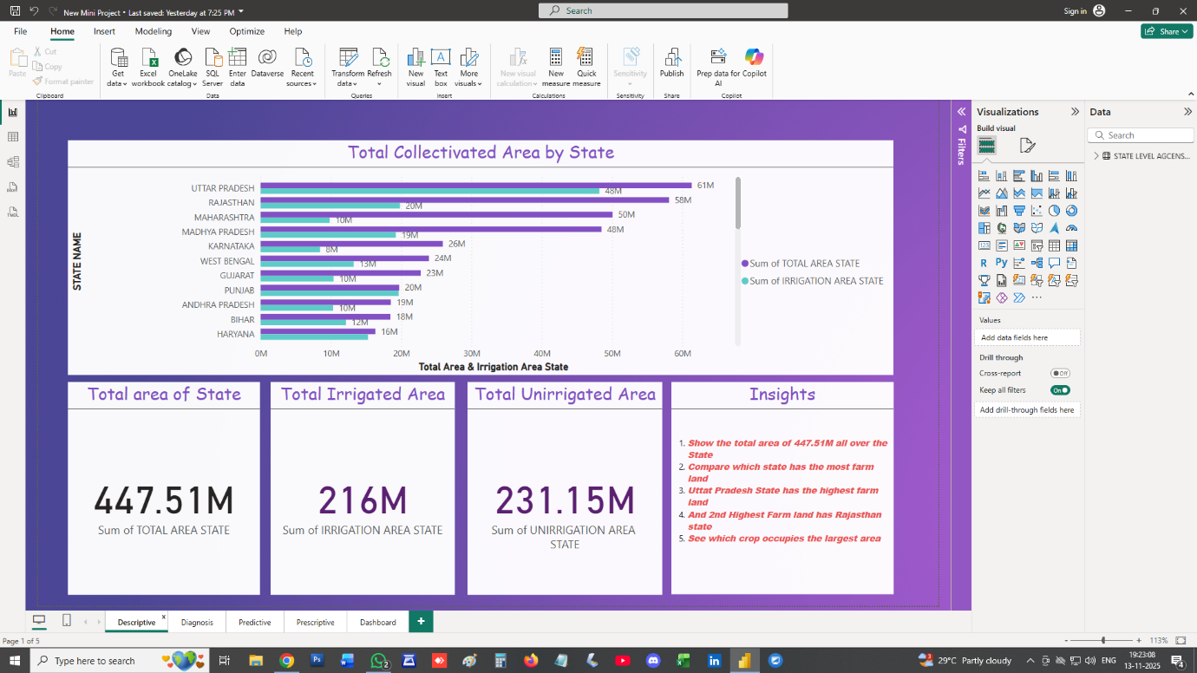

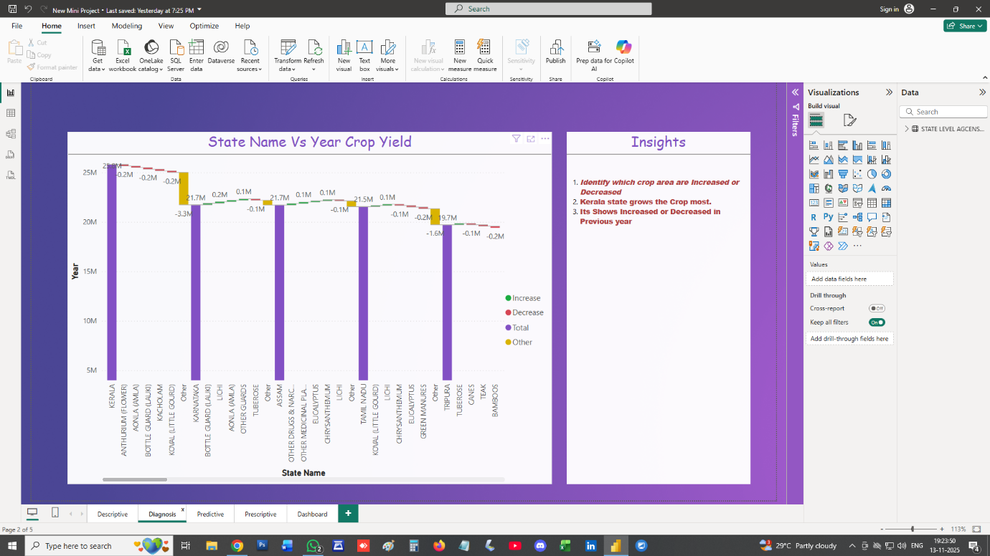

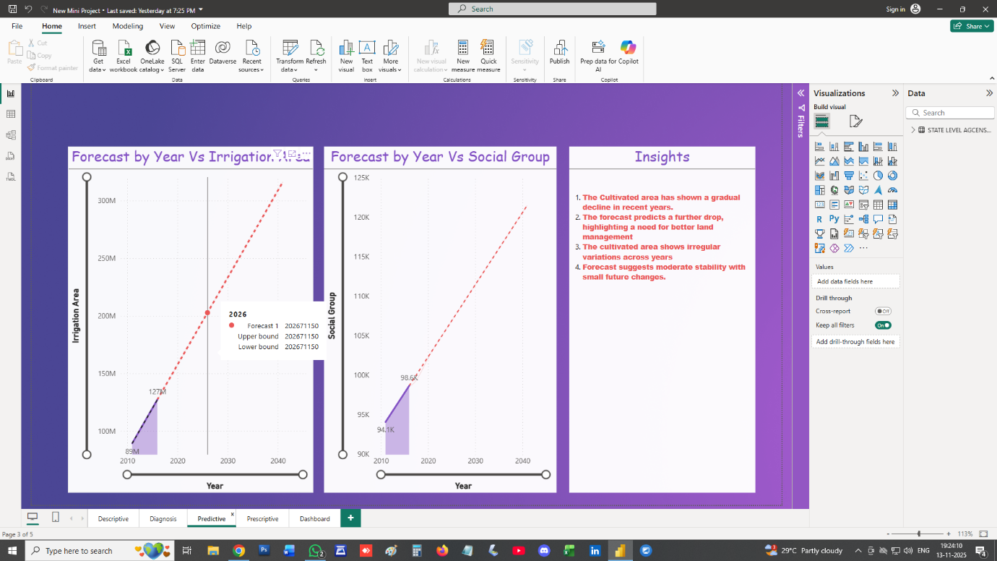
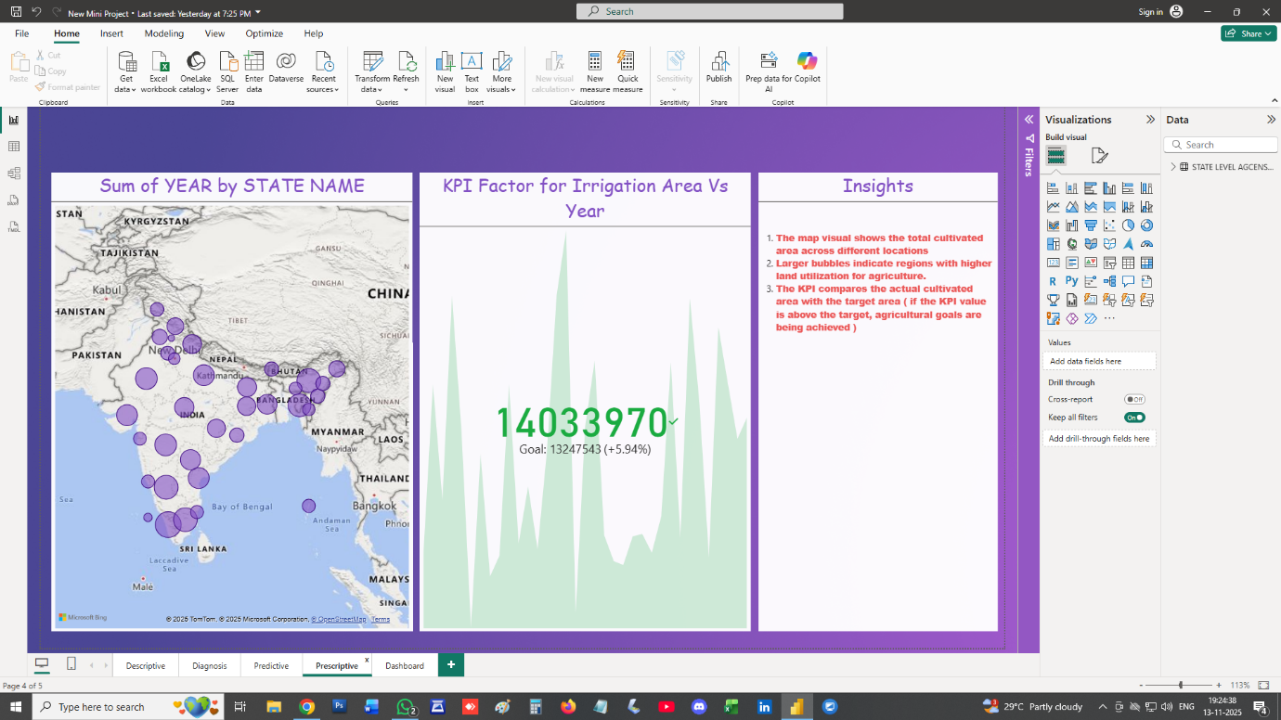

SCREENSHOT OF DASHBOARD /REPORT
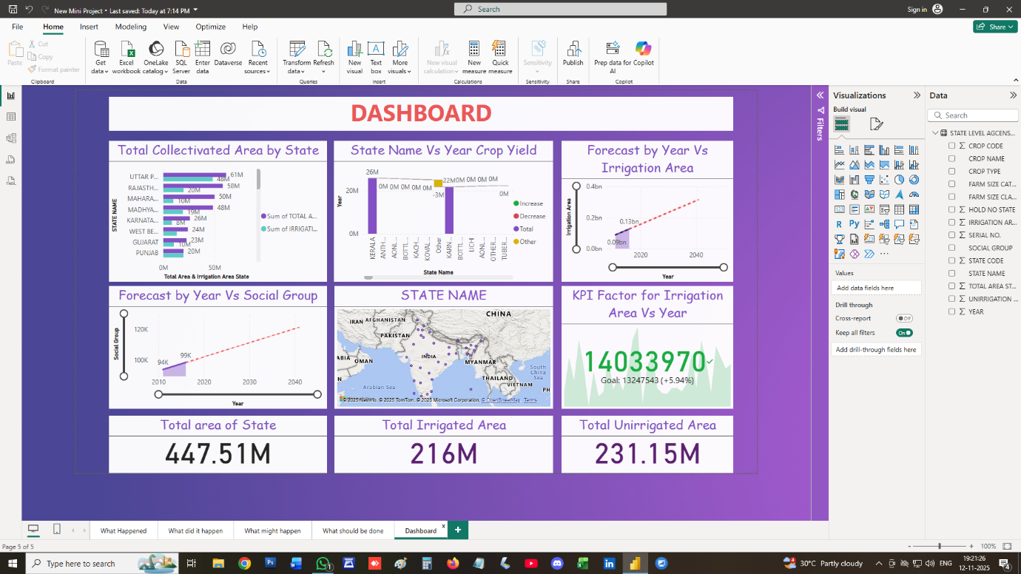

INSIGHTS
DESCRIPTIVE
- It shows the total area of 447.51M all over the State
- Compare which state has the most farm land
- Uttar Pradesh state has the highest farm land
- And 2nd highest farm land has Rajasthan State
- See which crop occupies the Largest Area
DIAGNOSIS
- Identify which crop area are Increased or Decreased
- Kerala state grows the crop most.
- Its shows Increased or Decreased in Previous Year.
PREDICTIVE
- The Cultivated area has shown a gradual decline in recent years.
- The forecast predicts a further drop, highlighting a need for better land management
- The cultivated area shows irregular variations across years.
- Forecast suggests moderate stability with small future changes.
PRESCRIPTIVE
- The map visual shows the total cultivated area across different locations.
- Larger bubbles indicate regions with higher land utilization for agriculture.
- The KPI compares the actual cultivated area with the target area (if the KPI value is above the target, agricultural goals are being achieved.)
CONCLUSION
The agricultural census dataset provides comprehensive insights into India’s crop production patterns across states and farm size categories. Analysis of irrigated and unirrigated areas reveals significant disparities between regions—states with better irrigation infrastructure consistently report higher productivity and larger cropped areas. Major crops such as paddy, wheat, maize, and pulses dominate total cultivated area, reflecting India’s staple food preferences.
State-level comparisons indicate that regions like Uttar Pradesh, Maharashtra, Madhya Pradesh, and Punjab contribute a substantial portion of the country’s total cultivated land. Coastal and northeastern states show smaller agricultural footprints but exhibit diverse crop types.
In summary, the dataset underscores the importance of irrigation infrastructure, landholding size, and crop diversification in shaping agricultural outcomes across India. These insights can guide policymakers in designing more targeted agricultural and irrigation development programs to improve productivity and sustainability.

